Coded Nursing Documentation (CND) Profile Proposal

1. Proposed Profile: Coded Nursing Documentation
Proposed Profile: Coded Nursing Documentation
Proposal Date: November 18, 2008
Status: Proposed
Version History: Version 1.0
Domain: Patient Care Coordination (PCC) IHE Technical Committee
Editors: Virginia K. Saba, EdD, RN; IHE PCC Member, vsaba@worldnet.att.net
LuAnn Whittenburg, MSN, FNP, CSC, lwhittenburg@csc.com
Keith Boone, keith.boone@ge.com
2. Brief Description of the Problem
Information technology with the health information exchange through IHE has become a significant force within healthcare. Recently, government and healthcare providers have begun to recognize the tremendous value and importance of advancing the use of healthcare information systems throughout the country. Without question, information technology and the management of information have become critical to the daily operations and strategic planning of healthcare organizations. And, while the issues of quality and appropriate, and the cost-effective use of resources has become focal concerns for consumers, politicians, and healthcare providers alike, there is an immediate need for nursing and allied health professionals to have access to domain specific clinical documentation for the greater effectiveness of integration/harmonization activities from a national quality of care perspective.

Currently, the federal government’s policy is to promote the highest quality of care at the lowest cost. The Office of Management & Budget has stated the current models of care are not aligned with the objective to provide the right care to the right patient at the right time. Currently, nursing care consumes 30% of the total hospital operating budget (Kane & Siegrist, 2002). And, experts anticipated the percentage will increase as of October 2008 when the Centers for Medicare and Medicaid Services (CMS, 2007) will no longer pay for nine “reasonable preventable” patient care conditions for which nurses have a major care responsibility such as injuries from patient falls, pressure sores, urinary-tract infections, etc.

The Agency for Healthcare Research and Quality (AHRQ) reports hospitals are experiencing a steady increase in patient care costs, along with a nursing resource shortage, as well as expanding healthcare regulation and policy requiring increased organizational information on care quality, safety, and outcomes. In 2006, healthcare spending rose 6.7% to $2.1 trillion or $7, 206 per person (Aaron et al, 2008). However, coded nursing/clinical documentation may be the most critical factor in a patient’s treatment and recovery (Gordon, 2005) and understanding the impact of nursing on patient care outcomes may be the key to improving quality in today’s healthcare system.

Today, clinical documentation by nurses represents one of the largest gaps of data required for inpatient care which includes the documentation of the complexity of patient conditions, and the time, depth, and costs of services performed by professional nurses. According to Welton, Zone-Smith, and Fischer (2006) “Hospital nursing care is invisible at the policy and payment levels of the health care system as no independent nursing data exist. For example: Assessments, Plans of Care, Clinical Pathways/Guidelines, Discharge Summaries, Consultations & Transfers, Continuity of Care & Referrals, and other formats used to communicate patient condition and status.

3. Use Case: Coded Nursing Documentation of Emergency Admission
The Coded Nursing Documentation (CND) Profile Proposal is in response to HITSP efforts to optimize healthcare interoperability and safe care for patients. The purpose is to facilitate the efficient and timely capture and analysis of nursing care events which, could or have had, an impact upon patient care outcomes using an electronic health record or health information system to provide useful outcome information to facility stakeholders and decision makers within the healthcare organizations as well as determine the resource requirements for implementing a comprehensive quality and patient care capability within healthcare.

The dilemmas for the configuration of a coded nursing documentation application are: What should be the focus, how much detail should be provided, and how responsive should the vendor be to make the application useable and “easy” for the nurses? The strategy chosen by the Clinical Care Classification (CCC) System (Saba, 2007) that was adopted by the Secretary of Health and Human Services, January 2008, upon recommendation from the Office of the National Coordinator for Health information Technology (ONC) Health Information Technology Standards Panel (HITSP) is to document and code only the ‘essence of care’ which primarily refers to the treatment of the patients presenting problems, e.g. to identify the nursing diagnosis based on the evaluation of the patient’s assessed signs and symptoms, followed by the selection of nursing interventions and actions needed to treat the patient and achieve the outcomes of the nursing care process. The strategy excludes reminders of what to look for and other unrelated information.

The Clinical Care Classification (CCC) System is a standardized Nursing Terminology which consists of atomic (data) concepts, each having a unique code and definition, making it possible to code nursing documentation as well as process electronic plans of care. Below is the proposal plan that identifies the scope of the IHE interoperability specification for the Coded Nursing Documentation (CDN) Profile Proposal.

3a. Model
The CCC System Model depicts the documentation of patient care by nurses and allied health providers in any health care setting as an interactive, interrelated, and continuous feedback process. The CCC System Model (Figure1) illustrates the relationship between the CCC of Nursing Diagnoses and Outcomes and the CCC of Nursing Interventions and Actions. The arrows are bi-directional indicating the continual flow and feedback among the three major concepts: nursing diagnoses, nursing interventions, and nursing outcomes.
Figure 1: Clinical Care Classification (CCC) Information Model

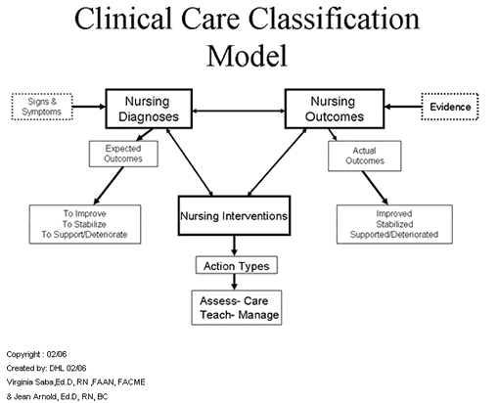
3a.1 Scope:
The Coded Nursing Documentation Profile Proposal using the CCC System Nursing Terminology encompasses the six phases of the system lifecycle for the IHE configuration. The profile includes:
- Planning
- Analysis
- Design
- Development
- Implementation
- Evaluation

3a.2 New actors:
- Nursing Terminology

3a.3 Existing actors:
- Electronic Health Information System
- Electronic Health Record, Electronic Medical Record, Electronic Patient Record
- Clinical Information System
- Computerized Provider Order Entry System

3a.4 New transactions (standards used):
- None anticipated

3a.5 Roles touched in the flow:
- Nurses, Attending Providers, Consulting Providers, Allied Health Professionals
3a.6 Systems:
- Healthcare Information Systems
- Healthcare Documentation System
- Electronic Medical Record Systems
- Personal Health Record Systems
- Computerized Provider Order Entry Systems
- Clinical Information Systems

3a.7 Standards:
- IHE XDS – MS
- HL7 Clinical Document Architecture (CDA); HL7 Continuity of Care Document (CCD)
- Clinical Care Classification (CCC) System – Coded Nursing Terminology

3b. Information Requirements:
Each of the system lifecycle areas and measurements are needed to satisfy clinical documentation information requirements that would permit the review or identification of practices that could improve the safe delivery and quality of health care. This information is based upon requirements created by the Clinical Care Classification (CCC) System Manual: a Guide to Nursing Documentation (Saba, 2007).

3b.1 Planning
Regardless of the documentation application being configured, a nursing informatics expert should take the lead and assist in directing the planning of the project. The plan should include: how the end product will look and how the Coded Nursing Documentation (CND) will be presented and used. The project leaders should be responsible for the configuration of the CND application for the electronic health record system using the CCC system and should consider the following major planning activities:
- Define its scope and design.
- Obtain administration support.
- Identify the nursing format for the CND using several possible approaches: 1) standardized; 2) individualize or 3) interactive:

3b.2 Analysis
The second phase is to conduct an analysis of the existing nursing documentation processes and determine changes and configuration. The analysis phase will include:
- Analyze existing nursing documentation
- Track the nurse care workflow
- Determine what content needs to be collected
- Determine what reports needs to be generated

3b.3 Design
The analyzed information is used to design the prototype for the actual IHE profile. This phase focuses on configuring the CND application.
- Design a model following the six steps of the nursing process (Figure 2)
- Determine functional specification and scope
- Determine level of specificity

Figure 2: Nursing Process Model (ANA, 1998)

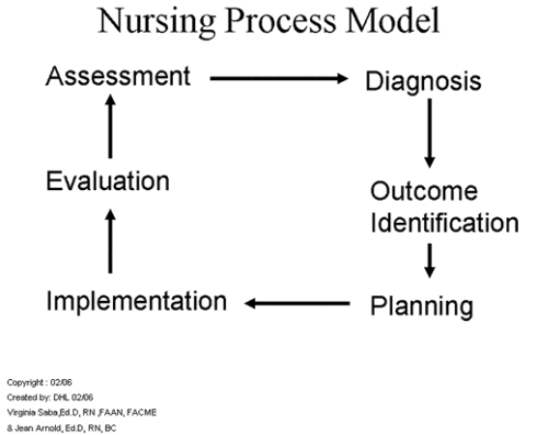
3b.4 Development
Once the design is completed the next phase is to configure the specific system specifications. The design includes:
- Develop inputs and outputs
- Link the selected system processes (tables)
- Design graphical user interface
- Design XDS-CCD screen accessible from all terminals within the electronic record
- Test and evaluate the profile using IHE test plans to test, revise, and retest continuously until CND is usable as designed

3b.5 Implementation
This phase demonstrates the Coded Nursing Documentation profile as an electronic record application and as an IHE Interoperability Profile and should consider:
- Provide technical, professional, and training support
- Establish the maintenance and update procedures.

3b.6 Evaluation
The evaluation and last phase is analyzed once the profile goes live to ensure that the IHE electronic Coded Nursing Documentation six code sets (Figure 3) are functioning as planned and configured. The evaluation phase consists of:
- Test the usability of the application
- Test the generation of reports
- Test the re-use and research applications
- Test the satisfaction of the users

Figure 3: Coded Nursing Documentation: Framework

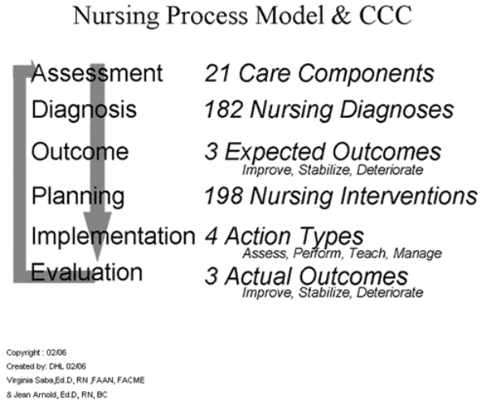
Only within the IHE Showcase can the Coded Nursing Documentation Profile determine the level of sale-ability of the vendor product that supports the national quality agenda. The vendor market share potential is based on product satisfaction as demonstrated in live EHR and as tested in the HIMSS IHE Interoperability Showcase.

3c. IHE Profile Steps
3c.1 Data: http://www.sabacare.com/Components/
Twenty-one (21) Care Components (Figure 4) of the Clinical Care Classification (CCC) System will provide the standardized framework for classifying Nursing Diagnoses, Nursing Interventions, and Nursing Outcomes for the Coded Nursing Documentation in the E H R system within the IHE profile. The Clinical Care Classification System Care Components are used to link, map, and track the nursing process for an episode of care for an illness as well as facilitate computer processing, and statistical analyzes. The Care Components include:1) Activity, 2) Bowel/Gastric, 3) Cardiac, 4) Cognitive, 5) Coping, 6) Fluid Volume, 7) Health Behavior, 8) Life Cycle, 9) Medication, 10) Metabolic, 11) Nutritional, 12) Physical Regulation, 13) Respiratory, 14) Role Relationship, 15) Safety, 16) Self Care, 17) Self Concept, 18) Sensory, 19) Skin Integrity, 20) Tissue Perfusion, and 21) Urinary Elimination.

Figure 4: Coded Nursing Documentation: Information Framework: Care Components for CCC Nursing Terminology

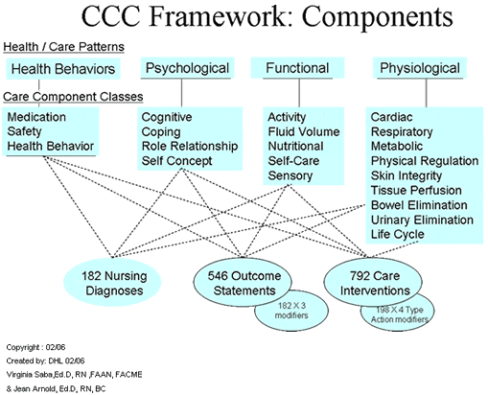
3c.2 Framework: http://www.sabacare.com/Framework/
These 21 Care Components code and classify the six steps of the Nursing Process (Figure 3):
1) Assessment (Care Component),
2) Diagnosis (Nursing Diagnosis),
3) Outcome Identification (Expected Outcome/Goal),
4) Planning (Nursing Intervention),
5) Implementation (Intervention Action Type), and
6) Evaluation (Actual Outcome).

3c.3 Coded Nursing Terminology: http://www.sabacare.com/Tables/Diagnoses.html?SF=DiagCode&SO=Asc
The CCC of Nursing Diagnoses consists of 182 Concepts and 546 Nursing Outcomes. Each Nursing Diagnoses requires the assignment of an Expected/Actual Outcome of the nursing care process, interventions/ actions. Three qualifiers are used not only to predict the care goals, but also to evaluate whether actual outcomes have met or not met the care goals e.g.
1) Patient=condition Improved;
2) Patient=condition Stabilized; or
3) Patient=condition Deteriorated i.e. died, discharged or transferred

3c.4 Interventions: http://www.sabacare.com/Tables/Interventions.html?SF=IntCode&SO=Asc
The CCC of Nursing Interventions consists of 792 Intervention Actions (198 Interventions plus 4 Action Qualifiers): (http://www.sabacare.com/Tables/ActionTypes.html)
1) Assess: Collect and analyze data on the health status;
2) Perform: Provide a therapeutic action;
3) Teach: Provide Information, knowledge and/or skill;
4) Manage: Coordinate, administrate, and/or refer.

3c.5 Outcomes: http://www.sabacare.com/Tables/Outcomes.html
The computable structure of the CCC System is already in the public domain which promotes upgrades to existing healthcare clinical documentation systems. A Service Oriented Architecture (SOA) implementation of standardized coded nursing terminology offers organizations a return on investment (ROI) on the value of nursing care including understanding productivity (workload), resources (staffing), and outcomes. This IHE profile will provide the necessary and crucial healthcare industry understanding of the relationship between nursing and quality outcomes.

3d. Current Process Flow
An example of the Coded Nursing Documentation application Use Case and the CCC System Nursing Terminology is used to code it is presented below. The CCC System standardized framework provides the nursing process as follows: 1) Care Component (Assessment), 2) Diagnosis (Nursing Diagnosis), 3) Goal (Expected Outcome), 4/5) Nursing Intervention & Action, and 6) Actual Outcome (Goal met or Not Met) follows:

Step 1: A patient presents to the Medical-Surgical Unit via the Emergency Department with the admitting diagnosis of Lithium toxicity. The patient was brought to the emergency room on Monday with altered level of consciousness, tremors and fever. Peak Lithium level on the day of admission was 2.0. The family and current medical history are obtained from the medical record and from speaking to the sister and brother. The patient is unable to effectively communicate due to mental confusion. The coded nursing documentation of a patient care using the Clinical Care Classification of a coded nursing terminology includes:

#1 Cognitive Care Component: (D)
Diagnosis: Confusion (D07.1)
Goal: Improve Confusion (D07.1.1) (Expected Outcome)
Intervention: Perform Reality Orientation (D11.0.2)
Outcome: Improved Confusion (D07.1.1) (Actual Outcome)

#2 Medication Care Component: (H)
Diagnosis: Medication Risk (H21.0)
Goal: Improve Medication Risk (H21.0.1) (Expected Outcome)
Intervention: Teach Medication Care (H24.0.3)
Outcome: Improved Medication Risk (H21.0.1) (Actual Outcome)

# 3 Role Relationship Care Component: (M)
Diagnosis: Communication Impairment (M28.0)
Goal: Improve Communication Impairment (M28.0.1) (Expected Outcome)
Intervention: Teach Communication Care (M38.0.3)
Outcome: Improved Communication Impairment (M28.0.1) (Actual Outcome)

In Step #1 (above), if the nursing terminology diagnoses noted in the patient’s coded nursing documentation were not recorded as part of a healthcare information system, the patient care deficit may go undocumented for a longer period of time presenting a barrier to healthcare quality and obstructing the patient’s continuity of care. By including nursing content i.e. terminology in the healthcare information systems, the caring organization is ensuring an appropriate level of care will be provided throughout the inpatient stay and interventions to enhance communication and collaboration among clinical members will continue to integrate nursing and associated health professional perspectives across all clinical activities.

Step 2: The continuity of patient care between shifts and specialty units is oral or hand written. While nurses work in increasing technological and information intensive environments, coded nursing documentation of patient care is currently unavailable neither for data analysis, staff education, nor for the integration of nursing interventions with quality outcomes due to the absence of a standardized nursing terminology in healthcare information management systems.

The IHE profile would demonstrate that coded nursing documentation, concept-based, information technology nursing terminology in electronic health records would be readily accessible to nurses, clinicians, attending providers and allied health professional staff at the care institution/organization and directly, quickly and accurately recorded into the organization’s health information system. The coded nursing documentation from each nursing unit could be available during the transfer of patient care between shifts or between and among specialty units within the institution. Without the ability to record data consistent with nursing expectations there is no unifying framework with which to compare impact of nursing interventions on quality outcomes.

3e. Proposed Flow if profile implemented
Step 2: The coded, concept-based, information technology nursing terminology for documenting the nursing care in electronic health records between shifts and all patient care settings is sent to the organization’s health information system database for retrieval from two geographically separated locations or from two separate healthcare systems to demonstrate CCD interoperability with coded nursing documentation of patient care content. The IHE profile would demonstrate that coded, concept-based, information technology nursing terminology for documenting the nursing care such as: assessments, plans of care, clinical pathways/guidelines, discharge summaries, consultations and transfers, continuity of care and referrals, and other formats used to communicate patient condition and status in the electronic health records. Such information is immediately available and readily accessible to the nurses, clinicians, attending providers and allied health professional staff and can be accurately recorded into the organization’s healthcare information system to support efficient and effective patient care quality as well as become an essential method for inter-disciplinary collaboration.

4. Discussion
The nursing profession through the American Nurses Association (ANA) has long recognized the need for quantitative evidence to measure the relationship of clinical documentation to the impact on patient care, and supply a scientific foundation for evidenced-based medicine. With the introduction of electronic health record systems (EHR) and clinical information systems as well as the Health and Human Services (HHS) adopting the Clinical Care Classification (CCC) System as a national health information standard for nursing terminology, organizations have the ability to modify clinical systems to collect clinical documentation data with specificity and determine the productivity (workload), resources (staffing), and outcomes as well as the cost for nursing service and support healthcare groups in accessing their own quality and outcome data.
5. Profile Summary
The Coded Nursing Documentation will require significant changes from current hospital practice as the organization migrates to electronic reporting and analysis of patient care data. A comprehensive change management strategy with an education and training plan on the new coded nursing documentation process and workflow is essential. The success of implementation and the ultimate realization of return on investment will depend on the execution of key aspects of change management. It is important that this transition to the new business process be given high-level oversight and constant attention from institutional leaders/vendors in the form of facility functional and technical support.

The IHE Coded Nursing Documentation using a Standardized Nursing Terminology addresses the need of clinicians and vendors for communication system to manage patient process within the nursing process, thereby optimizing healthcare quality and safety initiatives in the direct care system in order to reduce and /or prevent harm and control costs. The IHE Coded Nursing Documentation Profile will provide state of the art collecting, reporting, and storing of patient care information accurately with minimal investment of staff time. The CND solution will support patient care reporting using user dynamic screens and business rules with role-based security utilizing standard taxonomy for intuitive, fast and accurate data capture.

Upon completion of interoperability CND Profile by the IHE Patient Care Coordination Committee, the new generation of EHR systems could provide healthcare administrators, and others, timely and detailed reports in standard format and terminology on quality and patient care outcomes within their individual facilities/organizations. The outcome reports could then be analyzed for workload, resource use, and cost as well as be provided directly to multiple locations for interdisciplinary coordination of patient care as supported by The Joint Commission on Accreditation.

6. References

- Aaron. C., Cowan, C., Hartman, M., Heffler, S. (2008). National Health Spending in 2006: A Year of Change For Prescription Drugs. Health Affairs, January/February 2008; 27(1), 14-29.
- American Nurses Association (1998). Standards of Clinical Nursing Practice. Washington, DC: ANA.
- CMS Office of External Affairs, Fact Sheet, August 1, 2007
- Gordon, S. (2005). Nursing Against The Odds: How Health Care Cost Cutting, Media Stereotypes, And Medical Hubris Undermine Nurses And Patient Care (The Culture and Politics of Health Care Work), New York, NY, Cornell University Press
- Kane, N.M. & Siegrist, R.B. (2002). Understanding Rising Hospital Inpatient Costs: Key Components of Cost and The Impact of Poor Quality Retrieved from http://www.bcbs.com/Cost studies/reports/4_Inpatient_Qual_Assess.pdf
- Recognition as the 1st National Nursing Terminology, the Clinical Care Classification System (CCC by the Secretary of Health and Human Services; January 2007.
December 2006 accepted by the Office of the National Coordinator, Health Information Technology Standards Panel (HITSP), Bio-surveillance Use Case.
- Saba, V.K. (2007). Clinical Care Classification (CCC) System Manual: a Guide to Nursing Documentation. New York, NY, Springer Publishing
- Welton, J.M., Zone-Smith, L. & Fischer, M.H. (2006). Adjustment of Inpatient Care Reimbursement for Nursing Intensity, Journal of Policy, Politics, & Nursing Practice, (7) 4, 270-280.

